Tile: The Role of Implant Material in Complications After Cranioplasty: A Systematic Review and Meta-Analysis
Authors: James Malcolm, Ph.D.; Rima Sestokas Rindler, M.D.; Jason Chu, M.D.; Jason Allen, M.D.; Gustavo Pradilla M.D.; Faiz Ahmad, M.D., M.Ch.

Introduction:
Synthetic materials often replace autologous bone in cranioplasty after decompressive craniectomy. Complication rates of these materials have not been directly compared. This study reports a systematic review and meta-analysis comparing complication rates in patients undergoing autologous versus synthetic cranioplasty after craniectomy.

Methods:
A systematic literature search adherent to PRISMA guidelines was performed using PubMed and Scopus. Articles reporting complications related to cranioplasty material (autograft vs. synthetic) following craniectomy were included. Odds ratios [OR, 95% Confidence Interval (CI)] of overall complications, reoperation, and infection were pooled and compared. Resorption rates for autografts were also abstracted.

Results:
Twenty-six of 1344 articles met inclusion criteria (total 4156 patients; 2688 autologous vs. 1468 synthetic). Autologous material was associated with increased rate of reoperation (n=16, OR 1.62, CI 1.05-2.48, p=0.03). There was a nonsignificant trend for increased overall complications (n=14, OR 1.58, CI 0.93-2.67) and decreased rate of infection (n=25, OR 0.81, CI 0.54-1.21) for autografts. The resorption rate for autografts was 24.9.0% (n=402/1616).

Conclusion:
Autologous bone is associated with an increased rate of reoperation compared with synthetic material. There was no significant difference in overall complications or infection. Prospective studies should determine optimal material for cranioplasty.

Figure: PRISMA Flow Diagram

Figure: Reoperation
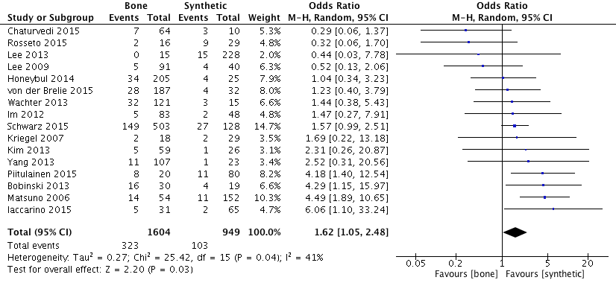

Figure: Any Complication
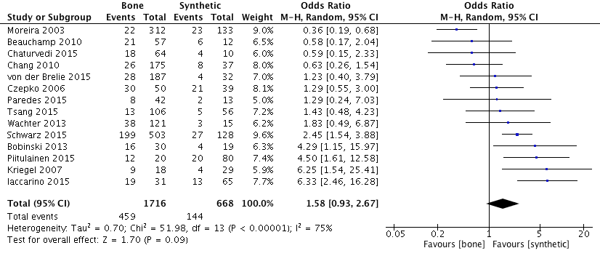

Figure: Infection
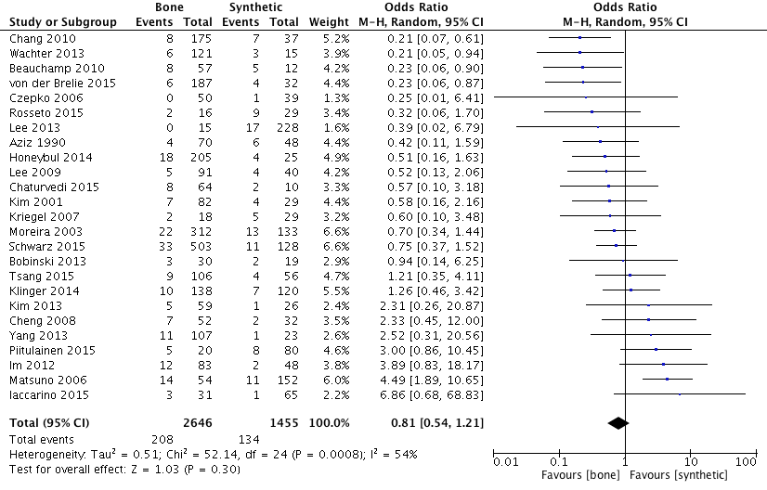

Future
- stratify synthetic materials into Titanium, PEEK, PMMA, etc.
- stratify resorption to determine rate that required reoperation

